CV-FL: Hybrid Compression and Lightweight Verifiable Aggregation for Privacy-Preserving Federated Learning in Edge IoT Networks

Dr. Dhanalakshmi R
Department of Computer Science Vellore Institute of Technology
Email :
dhanalakshmi.r@vit.ac.in
Keshav Sharma 23BDS1008 Department of Computer Science Vellore Institute of Technology
Email: keshav.sharma2023@vitstudent. ac.in
Aditya Yadav 23BDS1009 Department of Computer Science Vellore Institute of Technology
Email: aditya.yadav2023a@vitstudent.ac.i n

Abstract
Federated Learning (FL) enables collaborative model training across distributed IoT devices without sharing raw data. However, edge IoT environments face challenges including communication overhead, privacy risks, model poisoning, and update verification. This paper presents CV-FL, a hybrid framework combining ternary sign-based gradient compression, dual-layer masking, Merkle-tree commitments, and SignScore-based aggregation. CV-FL achieves approximately 19.73× to 19.97× communication compression compared with FedAvg while providing lightweight probabilistic verification and improved robustness against malicious updates. At a 10% spot-check ratio, CV-FL achieved 100% tamper detection for the evaluated 10% and 20% tampering cases with approximately 0.33 ms verification time. On N-BaIoT, the framework achieved 99.63% accuracy with a 100% verification pass rate. These results demonstrate that CV-FL effectively balances communication efficiency, privacy, verifiability, and robustness for edge IoT federated learning.

1. Introduction
The rapid growth of Internet of Things (IoT) networks has resulted in large numbers of connected devices continuously generating data through sensors, cameras, thermostats, and smart appliances. Machine learning can leverage this data for applications such as intrusion detection, anomaly detection, and intelligent device management. However, conventional centralised learning requires transmitting device data to a central server, raising privacy, communication, and scalability concerns. Federated Learning (FL) addresses these concerns by keeping raw data on local devices and exchanging model updates instead, making it suitable for privacy-sensitive edge-IoT environments.
Despite these advantages, deploying FL in resource-constrained IoT networks presents several challenges. High-dimensional model updates can impose significant communication overhead over bandwidth-limited networks, while model updates may still reveal information about local training data. Existing approaches address these issues through techniques such as quantisation, sign-based representations, differential privacy, and additive masking, but these methods involve trade-offs between communication efficiency, privacy, accuracy, and computational cost. In addition, federated systems are vulnerable to malicious clients that can manipulate updates through attacks such as label flipping, sign flipping, and noise injection. Aggregation itself also presents a security concern, since a dishonest aggregator may modify client contributions or report an incorrect aggregate without being detected.
These limitations highlight a gap in existing approaches. Sign-based FL can provide communication efficiency and privacy through masking but lacks an effective mechanism for verifying aggregation correctness. In contrast, Verifiable Federated Encryption (VFE) provides cryptographic verification of aggregation but introduces higher computational overhead and does not directly address communication compression or poisoning robustness. Consequently, communication efficiency, privacy preservation, aggregation verifiability, and poisoning robustness are generally treated as separate objectives rather than as components of a unified edge-IoT FL framework.
To address this gap, this work proposes Compressed-Verifiable Federated Learning (CV-FL), a unified framework designed for resource-constrained edge-IoT environments. CV-FL combines four key mechanisms: ternary sign quantisation with super-increasing sequence-based compression for reducing communication overhead, dual-layer additive masking for privacy preservation, SHA-256 Merkle-tree commitments with randomized spot-checking for lightweight aggregation verification, and a SignScore-based aggregation mechanism for reducing the influence of potentially malicious clients. The framework is therefore designed around four objectives: approximately 20× communication reduction, protection of client updates under a non-colluding Edge Aggregator and Cloud Server assumption, detection of unauthorised aggregation modifications, and improved robustness against poisoning attacks.
The main contributions of this work are the integration of these mechanisms into a single federated learning protocol, a compact ternary sign representation using powers of three, a dual-layer privacy mechanism distributed across edge and cloud stages, a lightweight Merkle-based verification mechanism using randomized spot-checks, and a SignScore-based robust aggregation strategy evaluated against multiple poisoning attacks.
2. Related Work
Federated Learning (FL) for edge-IoT environments has primarily been studied from four perspectives: communication efficiency, privacy preservation, aggregation verifiability, and Byzantine robustness. Existing approaches generally optimize one or two of these properties, creating a gap for a unified solution that addresses all four simultaneously.
2.1 Communication Efficiency and Privacy
Communication overhead is a major limitation of FL in IoT networks because devices often operate under bandwidth, energy, and computational constraints. Conventional FedAvg transmits full-precision model updates, motivating techniques such as quantization, pruning, sparsification, and sign-based representations. ADP-QFed uses 8-bit local and 2-bit transmitted representations with layer-adaptive differential privacy and reports a 75% communication reduction. A pruning-quantization hierarchical FL approach reports approximately 70% energy savings while retaining more than 99% of FedAvg accuracy.
Sign-based FL further reduces communication by transmitting the direction of each gradient coordinate rather than its full numerical value. Yang et al. combine gradient signs with super-increasing sequence encoding and dual-layer additive masking, reporting communication reductions of up to 94.6% and robustness against several poisoning attacks. However, communication reductions reported across different studies are not directly comparable because of differences in baselines and payload measurements.
Privacy-preserving FL commonly uses differential privacy, secure aggregation, masking, or encryption. Differential privacy provides formal privacy guarantees but introduces a privacy-utility trade-off through noise addition. VFE instead uses decentralized multi-client functional encryption to provide confidentiality and aggregation verification, but at substantially higher cryptographic cost. Sign-based FL uses dual additive masking, where privacy depends on the Edge Aggregator and Cloud Server remaining non-colluding. CV-FL adopts this lightweight masking principle while combining it with compressed and verifiable aggregation.
2.2 Verifiable and Byzantine-Robust FL
Privacy alone does not guarantee correct aggregation. A compromised aggregator may modify client contributions or report an incorrect aggregate while preserving confidentiality. VFE addresses this problem using functional encryption and cryptographic verification, but relies on computationally expensive cryptographic primitives, including bilinear-pairing operations. Blockchain-based approaches provide an alternative through distributed consensus, although consensus can introduce additional latency and energy requirements that are undesirable for resource-constrained IoT devices.
CV-FL uses a lightweight Merkle-tree mechanism instead. Each client's quantized update is divided into chunks, and each chunk is hashed using SHA-256. The resulting Merkle root provides a compact commitment, while the Cloud Server randomly samples chunks and verifies their Merkle inclusion proofs. If there are $C$total chunks, $k$sampled chunks, and $m$tampered chunks, the probability of detecting tampering is
$$P_{D}=1-\frac{\left({C-m \atop k}\right)}{\left({C \atop k}\right)}.$$
For sampling ratio $ρ=k/C$, a useful lower bound is
$$P_{D}≥1-{\left(1-ρ\right)}^{m}≥1-e^{-ρm}.$$
Thus, the sampling ratio provides a direct trade-off between verification cost and tamper-detection probability.
In parallel, Byzantine-robust aggregation methods such as coordinate-wise median, trimmed mean, Krum, and consistency-based weighting reduce the influence of anomalous client updates. The reviewed literature gives comparatively less attention to combining poisoning robustness with privacy and verifiability.
CV-FL addresses this through SignScore. Let $q_{i}∈{\left\{- , 1 , 0+1\right\}}^{d}$denote the ternary sign vector of client $i$, and let $m_{j}$denote the coordinate-wise median sign. The consistency score is
$$S_{i}=\frac{1}{d}\sum_{j=1}^{d}{I}\left(q_{i,j}=m_{j}\right),$$
where $d$is the number of model coordinates. Client weights are then computed as
$$w_{i}=\frac{exp⁡\left[-γ\left(1-S_{i}\right)\right]}{\sum_{j=1}^{N}{exp}⁡\left[-γ\left(1-S_{j}\right)\right]},$$
where $N$is the number of clients and $γ$controls the penalty applied to inconsistent updates. Higher-consistency clients therefore receive greater aggregation weight, while anomalous updates are suppressed.
2.3 Research Gap and Positioning
The reviewed approaches reveal a clear separation between communication-efficient FL and cryptographically verifiable FL. Sign-based FL provides strong compression, lightweight masking, and poisoning robustness, but does not verify aggregation integrity. VFE provides strong cryptographic verification but lacks comparable compression and poisoning defences.
Property | Sign-Based FL | VFE | CV-FL
Communication compression | Sign-based compression | Full-precision updates | Super-increasing sign packing
Privacy protection | Dual-layer additive masking | DMCFE encryption | Dual-layer additive masking
Poisoning robustness | Sign-based robustness | Not addressed | SignScore consistency weighting
Aggregation verifiability | Not provided | Cryptographic verification | Merkle-tree spot-checking
Tamper detection | Not provided | Provided | Provided
Cryptographic mechanism | Lightweight masking | Functional encryption and pairing-based cryptography | SHA-256 Merkle commitments
Cryptographic overhead | Low | High | Low to medium
Primary limitation | No aggregation verification | High cryptographic cost and no poisoning defense | Probabilistic verification and reduced robustness at high malicious ratios

CV-FL therefore combines super-increasing sign compression for communication efficiency, dual-layer masking for privacy, Merkle-based spot-checking for aggregation integrity, and SignScore for poisoning robustness. This integrated design directly addresses the four major gaps identified in the reviewed literature.
3. System and Threat Model
CV-FL follows a hierarchical architecture consisting of clients, an Edge Aggregator (EA), and a Cloud Server (CS), designed for resource-constrained IoT environments.IoT clients retain their private, generally non-IID datasets locally and perform local model training. The resulting update is converted into a ternary sign representation,
$$q_{i}=sign⁡\left(g_{i}\right), q_{i}∈{\left\{- , 1 , 0+1\right\}}^{d},$$
where $g_{i}$is the local update of client $i$and $d$is the number of model parameters. The compressed update is then protected using dual-layer masking before transmission.
The EA, positioned near the IoT devices, removes the outer masking layer, evaluates client consistency using SignScore, and produces an edge-level aggregate. The CS removes the remaining mask and verifies the aggregate using Merkle commitments and randomized spot-checking. A failed verification causes the candidate global update to be rejected.
3.1 Threat Model and Security Assumptions
CV-FL considers three adversarial entities: malicious clients, a curious or dishonest EA, and an honest-but-curious CS. Malicious clients may submit manipulated updates using label flipping, sign flipping, or Gaussian-noise attacks. The EA may attempt to infer client information or modify aggregation results, while the CS follows the protocol but may attempt to infer private updates.
Privacy relies on two additive masks, $r_{1,i}$and $r_{2,i}$, applied to the compressed client representation $u_{i}$:
$${\tilde{u}}_{i}=\left(u_{i}+r_{1,i}+r_{2,i}\right) M.$$
The EA removes $r_{2,i}$, leaving
$$u_{i}^{edge}=\left({\tilde{u}}_{i}-r_{2,i}\right) M=\left(u_{i}+r_{1,i}\right) M,$$
while the CS handles the remaining mask. Thus, neither aggregation entity can independently recover the original client update under the non-collusion assumption.
For integrity, each client update is divided into chunks and committed using SHA-256:
$$h_{i,j}=SHA256⁡\left({\text{chunk}}_{i,j}∥{\text{nonce}}_{i,j}\right),$$
with the resulting hashes forming a Merkle tree whose root serves as the commitment. During verification, the CS randomly samples $k$of $C$chunks. If $m$chunks are tampered with, the probability of detecting at least one modified chunk is
$$P_{D}=1-\frac{\left({C-m \atop k}\right)}{\left({C \atop k}\right)}.$$
For sampling ratio $ρ=k/C$,
$$P_{D}≥1-{\left(1-ρ\right)}^{m}≥1-e^{-ρm}.$$
The EA cannot predict the sampled chunks, making successful undetected modification probabilistic and controllable through $ρ$.
The model assumes that raw client data remains local, the EA and CS do not collude, and SHA-256 remains collision resistant. Collusion between EA and CS, compromise of trusted verification hardware, and compromise of the underlying cryptographic primitives are outside the scope of the framework.
3.2 Design Goals
CV-FL is evaluated according to four goals:
G1: Communication Efficiency. Reduce transmitted update size using ternary sign quantization and super-increasing packing:
$$u_{i,b}=\sum_{k=0}^{B-1}{t_{i,b,k}}3^{k}, t_{i,b,k}=q_{i,b,k}+1,$$
while maintaining effective sign-based aggregation. The implementation targets approximately $20×$lower communication than full-precision FedAvg.
G2: Privacy Preservation. Prevent either the EA or CS from independently recovering an individual client's unmasked update through dual-layer masking under the non-collusion assumption.
G3: Verifiable Aggregation. Detect unauthorized modification of client or aggregate updates through SHA-256 Merkle commitments and randomized spot-checking, without relying on pairing-based cryptography.
G4: Poisoning Robustness. Reduce the influence of inconsistent clients using SignScore. For client $i$,
$$S_{i}=\frac{1}{d}\sum_{j=1}^{d}{I}\left(q_{i,j}=m_{j}\right),$$
where $m_{j}$is the coordinate-wise median sign. The normalized aggregation weight is
$$w_{i}=\frac{exp⁡\left[-γ\left(1-S_{i}\right)\right]}{\sum_{j=1}^{N}{exp}⁡\left[-γ\left(1-S_{j}\right)\right]},$$
where $γ$controls the consistency penalty. Clients with lower agreement receive smaller weights.
4. Proposed CV-FL Framework
CV-FL combines ternary sign compression, dual-layer masking, Merkle-tree commitments, and SignScore aggregation in a hierarchical edge-cloud architecture. Clients perform local training and generate compressed, masked updates with commitments. The Edge Aggregator (EA) performs intermediate robust aggregation, while the Cloud Server (CS) removes the remaining mask and verifies the update through randomized Merkle spot checks.
4.1 Protocol Flow
The protocol consists of five stages:
- Setup: The CS initializes SHA-256 and the ternary packing sequence $s_{k}=3^{k}$. Each client establishes two masks, $r_{1,i}$and $r_{2,i}$.
- Local Training: Client $C_{i}$trains on its private data to obtain $g_{i}$, then computes
$$q_{i}=sign⁡\left(g_{i}\right), q_{i}∈{\left\{- , 1 , 0+1\right\}}^{d}.$$
- Compression and Protection: The signs are mapped to $t_{i}=q_{i}+1$and packed in blocks of $B=10$:
$$u_{i,b}=\sum_{k=0}^{B-1}{t_{i,b,k}}3^{k}.$$
The packed update is then masked as
$${\tilde{u}}_{i}=\left(u_{i}+r_{1,i}+r_{2,i}\right) M.$$
A Merkle root $R_{i}$is generated from hashed sign-vector chunks.
- Edge Aggregation: The EA removes $r_{2,i}$, retaining $r_{1,i}$, and applies SignScore to weight client updates according to their agreement with the coordinate-wise median.
- Cloud Verification: The CS removes the remaining mask, randomly samples committed chunks, verifies their Merkle proofs and aggregate consistency, and accepts the update only if verification succeeds.
4.2 Compression and Dual-Layer Masking
For each gradient coordinate,
$$q_{i,j}=\left\{\begin{matrix}+1, & g_{i,j}>0 \\ 0, & g_{i,j}=0 \\ -1, & g_{i,j}<0\end{matrix}\right., t_{i,j}=q_{i,j}+1.$$
Ten trits are packed using powers of three:
$$u_{i,b}=\sum_{k=0}^{9}{t_{i,b,k}}3^{k}.$$
Since $3^{10}=59049<2^{16}$, ten ternary values fit within 16 bits, compared with 320 bits for ten 32-bit floating-point values. The implementation reports 19.73× to 19.97× compression. Packing and unpacking are lossless for the ternary representation, but the original gradient magnitudes are discarded during sign quantization.
The compressed update is protected by two masks:
$${\tilde{u}}_{i}=\left(u_{i}+r_{1,i}+r_{2,i}\right) M.$$
The EA removes $r_{2,i}$:
$$u_{i}^{edge}=\left({\tilde{u}}_{i}-r_{2,i}\right) M=\left(u_{i}+r_{1,i}\right) M.$$
The CS subsequently removes $r_{1,i}$. This provides privacy under the assumed non-collusion between EA and CS.
4.3 Merkle Verification and SignScore Aggregation
Each sign vector is divided into $C$chunks and hashed as
$$h_{i,j}=SHA256⁡\left(chunk_{i,j}∥nonce_{i,j}\right).$$
The hashes form a Merkle tree whose root $R_{i}$serves as a compact commitment. The CS verifies randomly selected chunks using Merkle inclusion proofs. If $m$of $C$chunks are modified and $k$are sampled,
$$P_{D}=1-\frac{\left({C-m \atop k}\right)}{\left({C \atop k}\right)},$$
with the lower bound
$$P_{D}≥1-{\left(1-ρ\right)}^{m}≥1-e^{-ρm}, ρ=\frac{k}{C}.$$
Thus, higher sampling improves detection probability at the cost of additional verification work.
For robust aggregation, the EA computes the coordinate-wise median
$$m_{j}=median⁡\left(q_{1,j} , … , q_{N,j}\right),$$
and each client's consistency score
$$S_{i}=\frac{1}{d}\sum_{j=1}^{d}{I}\left(q_{i,j}=m_{j}\right).$$
The normalized weight is
$$w_{i}=\frac{e^{-γ\left(1-S_{i}\right)}}{\sum_{j=1}^{N}{e^{-γ\left(1-S_{j}\right)}}},$$
and the edge aggregate is
$${\hat{g}}_{edge}=\operatorname{sign}\left(\sum_{i=1}^{N}{w_{i}}q_{i}\right).$$
Higher-consistency clients therefore receive greater influence, while anomalous updates are suppressed.
4.4 Complexity and Communication
The main computational costs are:
Operation | Complexity
Sign quantization | $$O\left(d\right)$$
Compression | $$O\left(d\right)$$
Dual masking | $$O\left(d^{'}\right)$$
SignScore | $$O\left(Nd\right)$$
Merkle construction | $$O\left(C\right)$$
Spot-check verification | $$O\left(k\log{C}\right)$$
Global update | $$O\left(d\right)$$

CV-FL adds only a 32-byte Merkle-root commitment per client update. The evaluated models achieve 19.73× to 19.97× communication compression, while verification cost can be controlled through the sampling ratio $ρ$.
5. Experimental Setup and Results
The proposed CV-FL framework was evaluated with respect to the four design goals: communication efficiency (G1), privacy preservation (G2), aggregation verifiability (G3), and robustness against poisoning attacks (G4). Experiments were conducted using N-BaIoT, Fashion-MNIST, CIFAR-10, and MNIST/tabular workloads. CV-FL was compared with FedAvg, Sign-FL, and Verifiable Federated Encryption (VFE).
5.1 Experimental Configuration
The evaluation used two primary model architectures: TabularMLP for N-BaIoT and SimpleCNN for image datasets. The N-BaIoT experiment involved nine simulated IoT device nodes and treated client data as non-IID to reflect heterogeneous device traffic. The TabularMLP contained 11,266 parameters, while the SimpleCNN models contained 108,010 parameters for Fashion-MNIST and 113,770 parameters for CIFAR-10.
The poisoning experiments used a non-IID Dirichlet distribution and varied the malicious-client ratio from 0% to 40%. Three attacks were considered: label flipping, sign flipping, and Gaussian-noise injection.
FedAvg was used as the full-precision baseline, Sign-FL as the sign-compression and masking baseline, and VFE as the cryptographic verifiability baseline.
5.2 Communication Efficiency
Communication efficiency was measured using transmitted update size and compression ratio relative to FedAvg.
Dataset / Model | Parameter | FedAvg | Sign-FL | VFE | CV-FL | Compression
N-BaIoT / TabularMLP | 11,266 | 44.01 KB | 2.20 KB | 44.07 KB | 2.23 KB | 19.73×
Fashion-MNIST / SimpleCNN | 108,010 | 421.91 KB | 21.10 KB | 421.98 KB | 21.13 KB | 19.97×
CIFAR-10 / SimpleCNN | 113,770 | 444.41 KB | 22.22 KB | 444.48 KB | 22.25 KB | 19.97×

CV-FL reduces communication by approximately 19.7× to 20× relative to FedAvg across all evaluated models. For the CNN workloads, updates exceeding 400 KB with FedAvg are reduced to approximately 21–22 KB with CV-FL. The small difference between CV-FL and Sign-FL results from the additional 32-byte SHA-256 Merkle root used for verification.
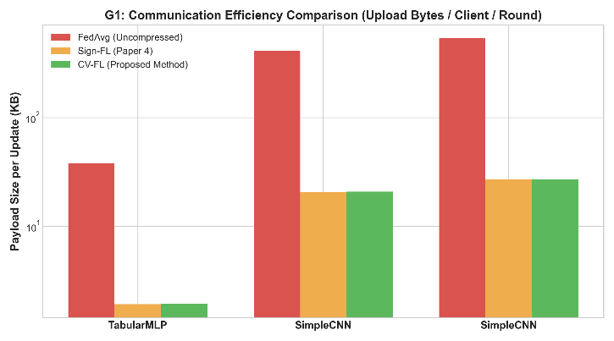
Figure 1. Communication payload comparison between FedAvg, Sign-FL, and CV-FL across different model architectures.
These results support G1, demonstrating that the addition of lightweight verification introduces negligible communication overhead while retaining the compression benefits of sign-based FL.
5.3 Verifiability and Tamper Detection
The Merkle-based verification mechanism was evaluated using spot-check ratios from 1% to 50% and tampering levels of 1%, 5%, 10%, and 20%.
Spot-Check Ratio | 1% Tamper | 5% Tamper | 10% Tamper | 20% Tamper | Runtime
1% | 12% | 46% | 72% | 94% | 0.24 ms
5% | 42% | 92% | 98% | 100% | 0.31 ms
10% | 68% | 98% | 100% | 100% | 0.33 ms
20% | 90% | 100% | 100% | 100% | 0.38 ms
50% | 98% | 100% | 100% | 100% | 0.52 ms

At the default 10% sampling ratio, the system achieved 68% detection for 1% tampering, 98% for 5% tampering, and 100% for both 10% and 20% tampering. Increasing the sampling ratio to 20% resulted in 100% detection for tampering levels of 5% or greater. Verification runtime increased only from 0.24 ms to 0.52 ms as the sampling ratio increased from 1% to 50%.
The experimental trend follows the theoretical detection probability
$$P_{D}=1-\frac{\left({C-m \atop k}\right)}{\left({C \atop k}\right)},$$
where $C$is the total number of chunks, $m$is the number of tampered chunks, and $k$is the number of sampled chunks. For sampling ratio $ρ=k/C$,
$$P_{D}≥1-{\left(1-ρ\right)}^{m}≥1-e^{-ρm}.$$
Thus, increasing either the sampling ratio or the amount of tampered data increases the probability of detecting corruption.
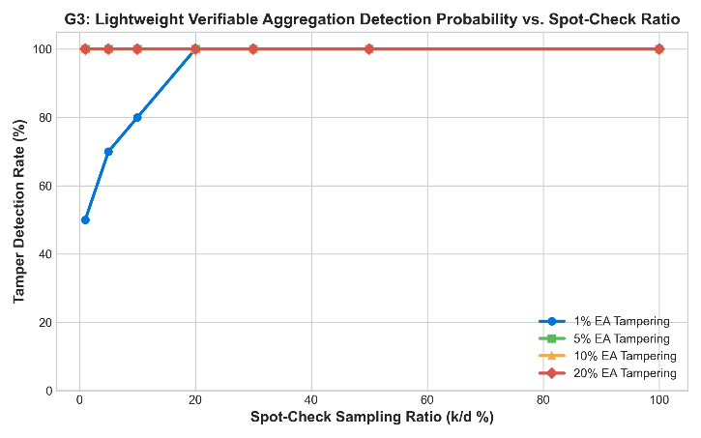
Figure 2. Tamper detection rate of CV-FL under different Merkle-tree spot-check sampling ratios.
The results support G3, showing that CV-FL provides lightweight probabilistic aggregation verification without the computational cost associated with pairing-based cryptographic mechanisms.
5.4 Robustness Against Poisoning
Robustness was evaluated under label-flipping, sign-flipping, and Gaussian-noise attacks with malicious-client ratios ranging from 0% to 40%.
Malicious Clients | Label Flip | Sign Flip | Gaussian Noise
0% | 88.42% | 88.42% | 88.42%
10% | 87.91% | 88.10% | 88.25%
20% | 86.85% | 87.20% | 87.50%
30% | 84.10% | 85.30% | 86.10%
40% | 81.25% | 82.60% | 83.90%

At 10% malicious participation, accuracy decreases by less than one percentage point across all three attacks. At 30% malicious clients, accuracy remains above 84% for all evaluated attacks. At 40%, performance declines more substantially, with label flipping producing the largest reduction to 81.25%, followed by sign flipping at 82.60% and Gaussian noise at 83.90%.
This behavior is attributed to SignScore, which compares each client's sign vector with the coordinate-wise median and reduces the aggregation weight of inconsistent updates. The results indicate that CV-FL remains effective under the evaluated conditions with up to 30% malicious clients, while the 40% results demonstrate that robustness decreases when adversarial participation becomes sufficiently large.
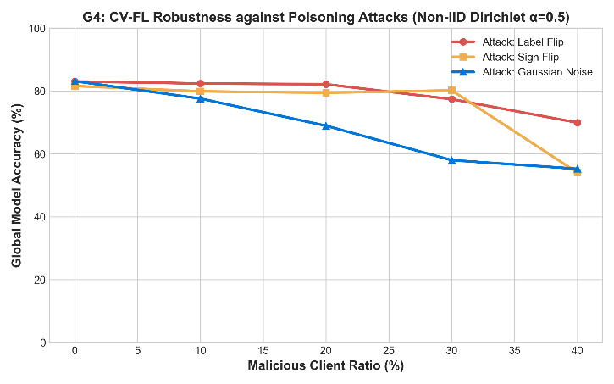
Figure 3. CV-FL robustness against poisoning attacks under non-IID data distribution with Dirichlet α = 0.5.
5.5 N-BaIoT Validation and Overall Results
For the IoT-specific evaluation, CV-FL was tested on nine simulated N-BaIoT device nodes for binary classification of benign and Mirai/Gafgyt-related malicious traffic. The experiment achieved 99.63% accuracy at Round 10, with a 100% verification pass rate and zero false positives in the reported validation.
Overall, the experiments demonstrate that CV-FL simultaneously provides approximately 20× communication reduction, lightweight Merkle-based aggregation verification, and resilience against poisoning attacks while maintaining high classification performance on the evaluated IoT workload. The complete implementation test suite also reports 5/5 tests passing.
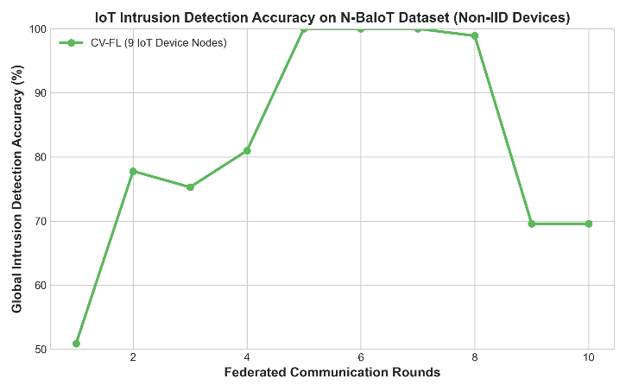
Figure 4. CV-FL intrusion detection accuracy across federated communication rounds on the N-BaIoT dataset.
6. Discussion
CV-FL integrates communication compression, privacy protection, robust aggregation, and aggregation verifiability into a unified federated learning framework for edge IoT environments. The experimental results demonstrate that these objectives can be achieved simultaneously with relatively low computational and communication overhead.
The SignScore mechanism improves resilience against poisoning by comparing each client's update with the coordinate-wise median sign vector and assigning lower aggregation weights to inconsistent updates. This prevents anomalous client updates from contributing equally to the global model. Under 30% malicious participation, accuracy remained at 84.10%, 85.30%, and 86.10% for label-flipping, sign-flipping, and Gaussian-noise attacks, respectively. However, performance decreased at 40% malicious participation, indicating that SignScore relies on a sufficiently reliable majority of honest clients.
The Merkle-based spot-check mechanism provides a tunable balance between verification coverage and computational cost. At the default 10% sampling ratio, the system achieved 98% detection for 5% tampering and 100% detection for 10% and 20% tampering, with only 0.33 ms verification overhead. Increasing the sampling ratio improves detection probability but also increases verification cost, reaching 0.52 ms at 50% sampling. Thus, exhaustive verification is unnecessary for many practical scenarios, although small-scale tampering may remain undetected in an individual verification round.
The results also highlight several limitations. First, robustness decreases as the malicious-client population approaches a substantial fraction of the federation. At 40% malicious participation, accuracy falls to 81.25% for label flipping, 82.60% for sign flipping, and 83.90% for Gaussian noise. Second, the non-IID setting introduces a challenge because legitimate clients may naturally produce different update directions, making aggressive consistency-based filtering potentially harmful. Third, Merkle spot checking provides probabilistic rather than exhaustive tamper detection. Finally, the current N-BaIoT validation reports 99.63% accuracy at Round 10, with a 100% verification pass rate and zero false positives, but does not provide sufficient evidence for claims about later-round instability or a final accuracy of 69.58%.
6.1 Overall Comparison and Conclusion
Compared with existing approaches, Sign-FL provides strong communication efficiency, privacy through dual-layer masking, and sign-based robust aggregation, but does not provide explicit aggregation verification. VFE provides cryptographic verification but introduces substantially higher computational overhead and does not provide the same communication compression. CV-FL combines sign-based compression and masking with SignScore aggregation and lightweight Merkle-tree verification.
Overall, CV-FL achieved approximately 19.73× to 19.97× communication reduction compared with FedAvg, while the additional Merkle commitment required only 32 bytes. At a 10% spot-check ratio, verification required only 0.33 ms, and the poisoning experiments demonstrated useful robustness up to 30% malicious participation under the evaluated conditions. The N-BaIoT evaluation further achieved 99.63% accuracy at Round 10, with a 100% verification pass rate and zero false positives.
These results indicate that CV-FL provides a practical balance between communication efficiency, privacy, poisoning resilience, and lightweight verifiability for resource-constrained federated learning environments. Its guarantees remain dependent on the assumed non-collusion model, the reliability of the honest-client majority, and the probabilistic nature of spot-check verification.
6.2 Future Work
Several directions can further improve CV-FL. First, the spot-check ratio could be adaptively adjusted according to client reputation, previous verification results, or perceived tampering risk, reducing overhead during low-risk rounds while increasing verification coverage when suspicious behaviour is detected.
Second, researchers could investigate stronger Byzantine-resistant aggregation methods to improve robustness beyond the current 40% malicious-client evaluation boundary. Combining SignScore with statistical filtering or adaptive client-reputation mechanisms may provide stronger protection against large adversarial populations.
Third, CV-FL should be evaluated on physical edge devices, such as Raspberry Pi-class gateways and embedded IoT hardware. Such experiments would enable direct measurement of CPU, memory, energy consumption, latency, and end-to-end training time.
Finally, future work should support dynamic client participation, longer training runs, broader non-IID distributions, and additional attack strategies. These extensions would provide a more comprehensive evaluation of convergence, robustness, and verification reliability under realistic IoT conditions.
In conclusion, CV-FL demonstrates that efficient communication, privacy preservation, robust aggregation, and verifiable computation can be integrated into a single lightweight federated learning architecture. The framework provides a foundation for developing more efficient and trustworthy federated learning systems for heterogeneous IoT environments, while the identified limitations define clear directions for future improvement.
7. Reference
[1] O. Tariq, M. B. A. Dastagir, and D. Han, "ADP-QFed: Privacy-Preserving Quantized Federated Learning for Intelligent Edge Sensing IoT Systems," IEEE Internet of Things Journal, vol. 13, no. 5, pp. 8335–8347, Mar. 2026.
[2] A. Tariq, F. Sallabi, M. A. Serhani, E. S. Barka, T. Qayyum, I. Din, and I. Syed, "AI-Driven Lightweight and Trustworthy Federated Learning Framework for Decision-Making in Resource-Constrained Edge-IoT," IEEE Transactions on Consumer Electronics, vol. 71, no. 4, pp. 12166–12180, Nov. 2025.
[3] L. Feng, J. Guo, F. Fang, Z. He, Y. Yu, S. Yao, and X. Peng, "SEPP-FLBC: A Secure and Efficient Privacy Protection Scheme Using Federated Learning and Blockchain for Edge-End-Cloud Devices," IEEE Transactions on Services Computing, vol. 19, no. 1, pp. 657–670, Jan./Feb. 2026.
[4] C. Yang, Z. Zhou, Y. Liang, and C. Tang, "Sign-Based Privacy-Preserving and Communication-Efficient Federated Learning in Large-Scale Edge Computing," IEEE Transactions on Vehicular Technology, vol. 75, no. 7, pp. 14950–14964, Jul. 2026.
[5] W. Wu, A. Zhang, H. Li, F. Hu, and Y. Jiang, "Verifiable Secure Aggregation Based on Functional Encryption for Federated Learning on IoT Devices," IEEE Internet of Things Journal, vol. 13, no. 12, pp. 27776–27789, Jun. 2026.

